PROJECT CHARTER

1. General Project Information
Project Name: |  | Ravenhill Coffee Shop Management System
Executive Sponsors: |  | Mr. Mehedi Hasan
Department Sponsor: |  | IT Department
Impact of project: |  | The project for Ravenhill Coffee Shop is to develop a secure web based Point of Sale system which will also include management tool for the daily running of the business. The system will automatically process orders and payments, hold stock levels of all items, hold customer information, take reservations and generate reports of all sales. This will enable the business to eliminate time consuming manual processes and increase the accuracy of information held, allowing staff to deal with customers in a fast and efficient manner. Replacing labor intensive manual processes with a secure and easy to use POS system the project will achieve its goal.
2. Project Team
 | Name |  | Department | E-mail
Team Members: | AL Ehsan Mahmud Ebon Masud |  | Database Design & AI Implementation | k232177@student.kentedu.au
 | Amisha Kumari Singh |  | UI/UX Designer & Frontend Developer | K231628@student.kent.edu.au
 | Shahriar Khan Tanvir |  | Frontend & Backend Developer | K231820@student.kent.edu.au
 | Sushil Bhusal |  | Testing/QA Analyst | k231952@student.kent.edu.au
 | Abhishek |  | Testing/QA Analyst | k231712@student.kent.edu.au
3. Stakeholders (e.g., those with a significant interest in or who will be significantly affected by this project)
Primary Stakeholders: |  | Fleur Studd and Jason Scheltus founder  Management  Administrator  Cashiers  Staff  Customers
Project Development Team: |  | AL Ehsan Mahmud Ebon Masud  Amisha Kumari Singh  Shahriar Khan Tanvir  Sushil Bhusal  Abhishek
External Service Providers |  | GitHub  Visual Studio Code  XMAPP  Web Hosting Provider  Trello  Antigravity
Mentor |  | Mr. Mehedi Hasan

4. Project Scope Statement
Project Purpose / Business Justification
This project aims to design and implement a secure web-based Coffee Shop Management system (hereinafter referred to as the “Ravenhill Coffee System”) to be used by the Coffee Shop at Ravenhill as a Point of Sale (POS) system. It will remove a large amount of the current manual processes involved in customer’s orders and menu management allowing on-line bookings, as well as stock, money transactions and production reports management. The system will aid management of the coffee shop helping to reduce errors and increase customer service, providing management with up-to-the minute information to assist with decision making. The system will also allow secure access by administrators, staff and cashiers on a role basis. The system must be user friendly and capable of supporting the day to day running of the coffee shop.
Objectives (in business terms)
●Handling of customers orders, online payment, reservations as well as stock management will be automated in order to decrease number of performed actions by at least 80%.
●Minimize data entry errors when processing customer transactions and increase overall processing accuracy. Test the system for a less than 5% error rate.
●Faster customers: Customers will get their orders processed faster. All orders will be processed and completed within less than 3 minutes. An integrated Point of Sale (POS) system for Order Processing is used to process orders.
● There will be an Role based access control so users will only have access to the functionality required for their role .
●Daily sales, stock and business reports are generated instantly and in less than 10 seconds, enabling fast and adequate business decisions.
●Auto Track Stock levels & automatically notify of low stock situations to avoid running out of stock & reducing stock waste.
Deliverables
List of high-level products to be created throughout the project:
•⁠ ⁠A secure User Authentication and Role-Based Access Control System for the Administrator, Staff and Cashier user types.
•⁠ ⁠Coffee Shop Point of Sale System making easier placement of orders and payment.
•⁠ ⁠Customer Management Module - customers will be able to register and their past purchases will be recorded for future reference.
•⁠ ⁠Menu and Product Customisation Module
•⁠ ⁠Table and Reservation Management System
•⁠ ⁠Low Stock Alert on Stock Management Module.
•⁠ ⁠Sales Reporting Dashboard with daily and monthly reports.
•⁠ ⁠Printable Receipt Generation System
•⁠ ⁠Database and Back-End Infrastructure for the application above using PHP and MySQL.
•⁠ ⁠Project Documentation: Software Requirements Specification (SRS), Entity Relationship Diagram (ERD), Data Flow Diagrams (DFDs), Use Case Diagrams, Class Diagrams, Test Plan, User Manual, and Final Report.
Project Phases
Phase 1 – Planning & Requirements Gathering
•⁠ ⁠Analyse business requirements
•⁠ ⁠Gather functional and non-functional requirements
•⁠ ⁠Prepare the Project Charter and Interim SRS
Phase 2 – System Analysis & Design
•⁠ ⁠Finalise the Software Requirements Specification (SRS)
•⁠ ⁠Design ERD, DFDs, Use Case Diagrams, and Class Diagrams.
•⁠ ⁠Design the system architecture and user interface
Phase 3 – Database & Back-End Development
•⁠ ⁠Create and configure the MySQL database
•⁠ ⁠Develop user authentication and role-based access control
•⁠ ⁠Implement core business logic using PHP
Phase 4 – Module Development
•⁠ ⁠Develop the POS, Customer, Menu, Reservation, Inventory and Reporting modules.
•⁠ ⁠Integrate payment processing and receipt generation
•⁠ ⁠Develop the administrator dashboard
Phase 5 – Integration & Testing
•⁠ ⁠Integrate all system modules
•⁠ ⁠Perform unit, integration, and system testing
•⁠ ⁠Conduct User Acceptance Testing (UAT)
Phase 6 – Deployment & Documentation
•⁠ ⁠Deploy the application to the project server
•⁠ ⁠Prepare the User Manual and Technical Documentation
•⁠ ⁠Fix final defects and optimise the system
Phase 7 – Final Report & Presentation
•⁠ ⁠Submit the completed project and all documentation
•⁠ ⁠Demonstrate the completed Coffee Shop Management System
•⁠ ⁠Present the project outcomes and answer questions
Scope
The purpose of this project is to design and implement a secure web-based system called Ravenhill Coffee Shop Management System for managing the coffee shop on a day to day basis. It will allow users to log into the system with access to different functions based on their role. It will allow customers to be added to the system, menus to be added and managed, menu items to be added and customized as required by customers. It will allow management of tables and taking of reservations. It will allow ordering and payment by customers with generation of receipts for customers. It will allow management of stock, recipes for products, suppliers and purchases by those suppliers. It will allow monitoring of attendance of employees. It will allow customers to give feedback. It will allow management of customers’ loyalty program. Reports will be generated by the system for analysis by management for making informed and correct decisions. The system will also generate real-time sales report and stock report to help the management of the coffee shop to operate efficiently.
The following are excluded from this project as they fall outside of the scope of an academic project or are beyond the resources or time available for this project. These elements are not exhaustive of all potential development for the system, but do represent some of the potential future work. A mobile application, 3rd party accounting/ERP system integration, multi-branch capability, online food delivery platform integration, or enterprise level cloud hosting.
Project Milestones
Project Milestone | Start Date | End Date
Assessment 1 – Weekly Project Review | Week 1 | Week 12 (Weekly)
Assessment 2 – Interim Software Requirements Specification (SRS) Report | Week 1 | Week 3
Assessment 3 – Final Software Requirements Specification (SRS) Report | Week 3 | Week 5
Assessment 4 – SRS Presentation | Week 5 | Week 6
Assessment 5 – Mid Project Deliverables (Prototype & Core Modules) | Week 6 | Week 9
Assessment 6 – End Project Deliverables (Final System & Documentation) | Week 9 | Week 11
Assessment 7 – Formal System Demonstration | Week 11 | Week 12

Major Known Risks (including significant Assumptions)
Risk | Risk Rating (High, Medium, Low)
Delays in completing project milestones due to developer communication | High
Integration issues between frontend, backend, and database modules | High
Data breach or unauthorised access to customer and business information | High
SQL Injection, Cross-Site Scripting (XSS), or other web security vulnerabilities | High
Loss or corruption of project data due to inadequate backup procedures | Medium
Team member unavailability or uneven workload distribution | Medium
Bugs or defects discovered during testing that delay deployment | Medium
Changes to project requirements during development | Medium
Failure to meet system performance and response time requirements | Medium
Compatibility issues across different web browsers or devices | Low

Constraints
Time Constraints:
The project has time constraints as it is to be completed within the 12 week trimester in which the assessment schedule outlines the work to be completed. Unfortunately this means that there will not be sufficient time to include all the features that could be in the system and to test and refine the system that has been developed to ensure that it is working properly.

Resource Constraints:
The project is being completed by a team of 5 students, all studying full time for other courses throughout the year. They will be utilizing open source software in the development of the project.

Technical Constraints:
This system will be a web-based application. Therefore it will be developed using PHP and MySQL. There are no plans to develop any native mobile applications. There is no use of any AI outside of this project. No cloud-based enterprise deployment. No system integration with any other third party systems.

Testing Constraints:
For the testing of this project, mainly the members of the project team and a handful of users of the system will be testing the system. Due to the constraints of time and resources, large-scale testing for performance, security and usability will not be possible.

Budget Constraints:
This is an academic project, therefore there is no allocated project budget. We will use free software wherever possible and try to host the project on free hosting.

External Dependencies
External Factors – Yes. The project will not get completed without the aid of the project team, the project mentor and the client (Ravenhill Coffee). Collecting and validating the requirements of the system, design and development of the system and testing of the system for faults, completing the final documentation for the system. The project team will hold regular meetings with the project mentor, including progress reviews and feedback. All team members have agreed to work as a team to complete the project and ask for feedback and support from all stakeholders as and when needed.

5. Communication Strategy
Stakeholder | Communication Method | Frequency | Purpose
Project Team | Weekly face-to-face ,Trello, Microsoft Teams,WhatsApp, GitHub, Google Drive | Daily and Weekly | Discuss progress, assign tasks, resolve issues, and monitor project milestones
Project Manager (Ebon) | Team meetings, progress reports, project schedule reviews,Trello Update. | Weekly | Coordinate team activities, monitor project progress, and ensure timely completion of deliverables
Executive Sponsor (Mr. Mehedi Hasan) | Email updates, consultation meetings, milestone reports | At major milestones or as required | Review project progress, provide guidance, and approve major deliverables
Ravenhill Coffee Management (Fleur Studd & Jason Scheltus) | Email updates, system demonstrations, feedback meetings | At major milestones (Weeks 3, 5, 9, 11 & 12) | Validate business requirements, review system functionality, and provide feedback
Coffee Shop Staff (User Testers) | User Acceptance Testing (UAT), demonstration sessions, meetings, online feedback forms | During Testing Phase (Weeks 9–11) | Test system functionality, identify issues, and provide usability feedback
External Service Providers | Email, online meetings, technical support requests | As Required | Provide technical assistance for hosting, software tools, and development resources

6. Sign-off
 | Name | Signature | Date (MM/DD/YYYY)
Executive Sponsor | Mr. Mehedi Hasan
Department Sponsor | Kent Institute
Project Manager | Al Ehsan Mahmud Ebon Masud

7. Notes
NA

Interim Software Requirements Specification (SRS)
Project: Ravenhill Coffee Shop Management System
Unit: CPRO306 Capstone Project
Assessment 2 – Interim SRS Report

Executive Summary
This interim SRS shows and goes through the requirements, scope and planning for the Ravenhill Coffee Shop Management System which will be a secure web based POS system that will be managing orders, inventory, reservations, payments and also reporting.

1. Introduction
The system will replace manual processes that has been done with a secure POS system that will be supporting Administrator, Staff and Cashier roles in the business. It improves operational efficiency, reporting accuracy and customer service while ensuring secure access to business information. As Software requirements play a critical role in defining business needs and improving software quality before implementation according to Rączkowska-Gzowska & Walkowiak-Gall 2023.

2. Purpose, Scope and Objectives

Purpose
Deliver a secure, reliable and user-friendly POS system for Ravenhill Coffee.
Objectives
- Automate sales transactions.
- Improve inventory management.
- Reduce manual errors.
- Generate accurate sales reports.
Scope
- Login
- Menu Management
- Orders
- Payments
- Reservations
- Inventory
- Reporting
Out of Scope
- Mobile application
- Accounting integration
- Multi-branch management
according to Sommerville 2016 having a clear breakdown of this clearly shows the project scope and the objectives helps reduce Vagueness and supports successful software delivery.

3. Project Description
The system will provide a secure authentication with security adding order managing system, payment processing, printable receipts and business reports for Ravenhill Coffee.The proposed solution is designed to improve efficiency over the manual workload while maintaining high standards of security and usability.according to Bekmanova et al. 2024 having web based system that is secure can improve and bring stability in usability.

4. Stakeholder Analysis

Stakeholder | Interest | Responsibility
Owner | High | Approves project
Admin | High | System management
Cashier | High | Sales
Staff | Medium | Operations
Customers | High | Use services
Effective stakeholder involvement contributes significantly to successful software requirement identification and implementation (Belfo 2012).

5. Project Team and Roles

The project team consists of a Project Manager, a Database and AI Developer, a UI/UX and Frontend Developer, a Frontend and Backend Developer, and two QA/Test Analysts. Sommerville ( 2016 ) said each member is responsible for completing their assigned tasks while working collaboratively throughout the software development lifecycle this makes it more reliable and efficient.

6. Functional Requirements
The system shall provide the following functionality:
- User Login
- Customer Management
- Menu Management
- Order Processing
- Reservation Management
- Payment Processing
- Inventory Management
- Reporting Dashboard
Functional requirements describe the services the software must provide to meet business needs (IEEE Computer Society n.d.).

7. Non-functional Requirements
The system should satisfy the following quality requirements:
- Performance (page response within three seconds)
- Security (Role-Based Access Control and password hashing)
- Usability (simple and intuitive interface)
- Reliability (database backup and recovery)
- Availability (high system uptime)
Non-functional requirements ensure software quality, usability and long-term maintainability (Rączkowska-Gzowska & Walkowiak-Gall 2023).

8. Work Breakdown Structure (WBS)
- Planning
- Requirements Gathering
- System Analysis
- Design
- User Interface Design
- Database Design
- Development
- Frontend Development
- Backend Development
- Testing
- Deployment
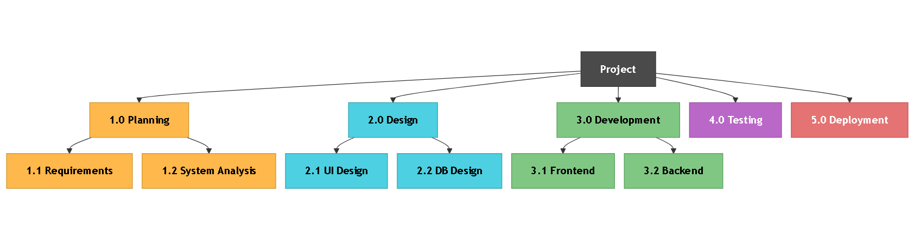
A Work Breakdown Structure provides a structured approach to project planning and resource allocation (Sommerville 2016).

9. Project Milestones

Phase | Weeks
Requirements | 1-3
Design | 4-5
Development | 5-8
Testing | 9
Deployment | 10
These milestones provide measurable checkpoints for monitoring project progress (Sommerville 2016).

10. Gantt Chart
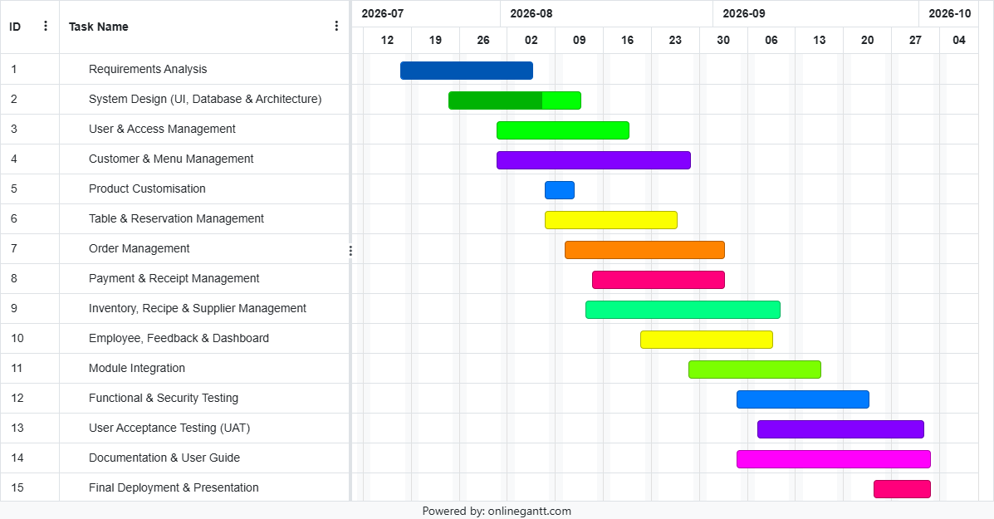
https://trello.com/c/uuhjS6Jp ( Gantt Chart)
https://www.onlinegantt.com/#/gantt (need to use this to open the Gantt chart)

11. 0 DFD Diagram

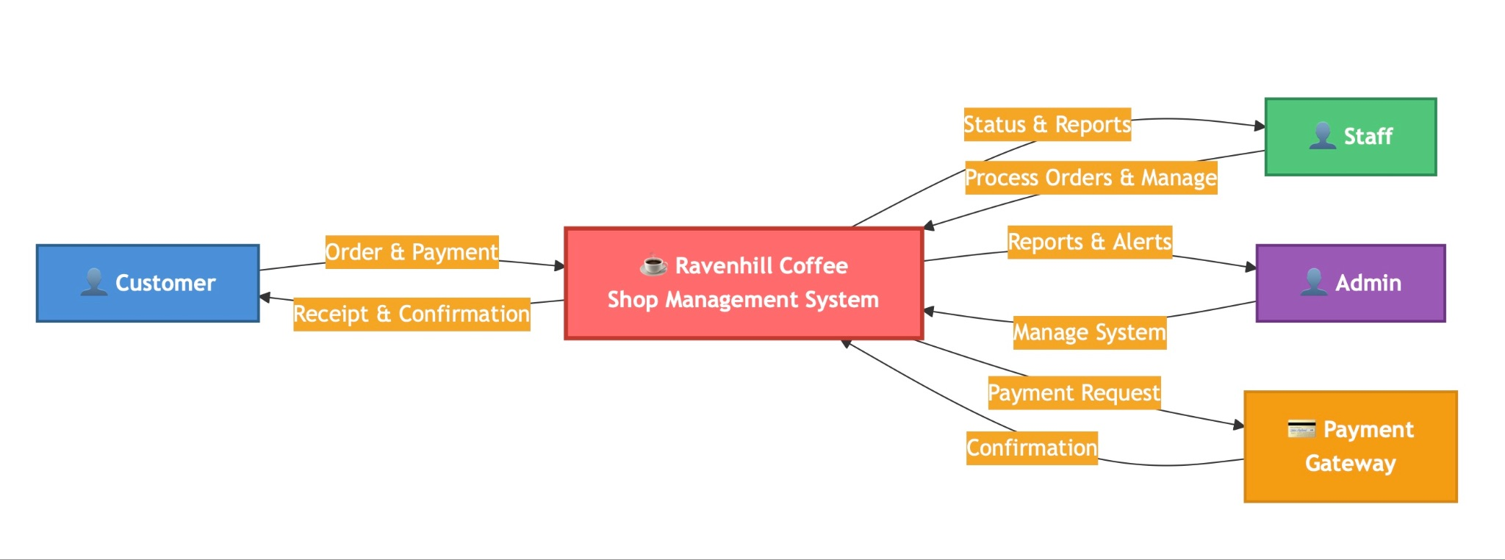

11. Budget Summary
Item | Cost
Development | $35,000
Software & Hosting | $2,500
Testing & Quality Assurance | $3,000
Documentation & Deployment | $2,000
Contingency | $5,000
Total Estimated Cost | $47,500

The estimated budget is appropriate for developing a Mid-scale academic web application using open-source technologies.

12. Risk Analysis

Risk | Likelihood | Impact | Mitigation
Data breach | High | High | Encryption/RBAC
Delay | Medium | Medium | Weekly reviews
Data loss | Low | High | Backups

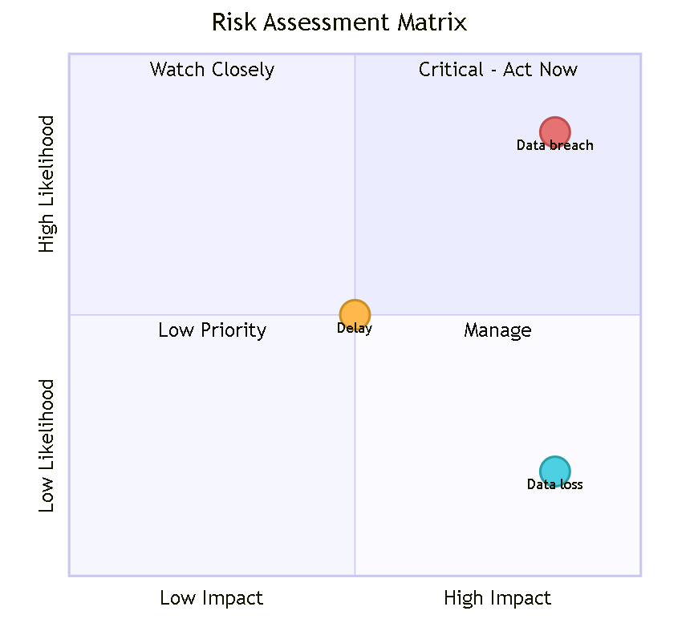

Risk management reduces uncertainty and supports successful software implementation (Belfo 2012).

13. Ethical Risks in Database Design and Mitigation

The project will protect customer privacy by collecting minimal personal data, encrypting sensitive information, monitoring and record-keeping, and user access restrictions.Bekmanova et al. (2024) highlights that ethical database practices enhance trust and promote responsible use of users' data.

14. Communication Plan

Audience | Method | Frequency
Team | Meetings | Weekly
Client | Email/Demo | Fortnightly
Lecturer/client | Progress update | Weekly
Regular communication improves stakeholder collaboration and project success (Belfo 2012).

15. Feasibility Study
Area | Summary
Technical | Xmapp MySQL suitable
Operational | Easy for staff
Economic | Open-source reduces cost
Legal | Privacy/security compliance
Schedule | Achievable in trimester (12 weeks)
Sommerville (2016) explains that feasibility study evaluates whether the proposed solution is technically, operationally and economically practical before development begins

16. Key Deliverables

Deliverable | Description
Interim SRS | Requirements
Prototype | UI
Database | ERD & schema
POS System | Working application
Testing | Test report
Presentation | Final demo
These deliverables provide measurable outcomes throughout the project lifecycle.

17. Findings and Recommendations
The proposed POS system will improve operational efficiency, reduce manual processing errors, accuracy of inventory, and reporting. To ensure maximum system reliability and safeguard sensitive business data,implementing strong security measures, regular backups, and user training is recommended by Rączkowska-Gzowska & Walkowiak-Gall 2023.

18. Lecturer Feedback Response
No formal feedback had been received at the time of preparing this interim report. Future feedback will be incorporated into the final SRS.

19. Conclusion
The Ravenhill Coffee Shop Management System is technically, economically and operationally possible. The proposed solution fulfills the identified business requirements while providing secure, efficient and scalable support for coffee shop. According to Belfo (2012) and Sommerville (2016), successful software development and implementation is based on a comprehensive Software Requirements Specification.

References

Bekmanova, G, Yergesh, B, Omarbekova, A, Orynbay, L, Bessembayeva, A, Kabdylova, D, Zulkhazhav, A & Sultan, B 2024, 'Requirements for the Development of a Website Builder with Adaptive Design', 2024 9th International Conference on Computer Science and Engineering (UBMK), IEEE, pp. 265–270.
Belfo, F 2012, 'People, organizational and technological dimensions of software requirements specification', Procedia Technology, vol. 5, pp. 310–318.
IEEE Computer Society n.d., Software Requirements Specifications, viewed 25 July 2026, https://www.computer.org/resources/software-requirements-specifications#what-is-a-software-requirement.
Rączkowska-Gzowska, K & Walkowiak-Gall, A 2023, 'What should a good software requirements specification include? Results of a survey', Foundations of Computing and Decision Sciences, vol. 48, no. 1, pp. 57–81.
Sommerville, I 2016, Software Engineering, 10th edn, Pearson Education, Harlow.

